INSTALL WINE5 ON UBUNTU 18.04

Open this <https://wiki.winehq.org/Ubuntu>

Paste this on terminal

sudo dpkg --add-architecture i386

wget -nc <https://dl.winehq.org/wine-builds/winehq.key>

sudo apt-key add winehq.key

sudo add-apt-repository 'deb <https://dl.winehq.org/wine-builds/ubuntu/> bionic main'

sudo apt update

sudo apt install --install-recommends winehq-stable

But i got this massage

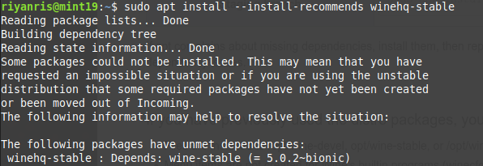

Some packages could not be installed. This may mean that you have

requested an impossible situation or if you are using the unstable

distribution that some required packages have not yet been created

or been moved out of Incoming.

The following information may help to resolve the situation:

The following packages have unmet dependencies:

winehq-stable : Depends: wine-stable (= 5.0.2~bionic)

Browsing dikit nemu ini <http://ubuntuhandbook.org/index.php/2020/01/install-wine-5-0-stable-ubuntu-18-04-19-10/>

coba perintah ini

sudo apt-get install libgnutls30:i386 libldap-2.4-2:i386 libgpg-error0:i386 libxml2:i386 libasound2-plugins:i386 libsdl2-2.0-0:i386 libfreetype6:i386 libdbus-1-3:i386 libsqlite3-0:i386 libgnutls30:i386 libldap-2.4-2:i386 libgpg-error0:i386 libxml2:i386 libasound2-plugins:i386 libsdl2-2.0-0:i386 libfreetype6:

sudo aptitude install wine-stable

Dan belum berhasil

Perintah ini buat copot yang tadi asal ku install

sudo apt-get remove libgnutls30:i386 libldap-2.4-2:i386 libgpg-error0:i386 libxml2:i386 libasound2-plugins:i386 libsdl2-2.0-0:i386 libfreetype6:i386 libdbus-1-3:i386 libsqlite3-0:i386 libgnutls30:i386 libldap-2.4-2:i386 libgpg-error0:i386 libxml2:i386 libasound2-plugins:i386 libsdl2-2.0-0:i386

Trus browsing lagi nemu ini

<https://nixytrix.com/error-winehq-stable-depends-wine-stable-5-0-0-bionic/>

Coba perintah ini

wget -nv https://download.opensuse.org/repositories/Emulators:/Wine:/Debian/xUbuntu_18.04/Release.key -O /tmp/Release.key

sudo apt-key add - < /tmp/Release.key

sudo apt-add-repository 'deb https://download.opensuse.org/repositories/Emulators:/Wine:/Debian/xUbuntu_18.04/ ./'

sudo apt-get update

Lalu

sudo apt install --install-recommends winehq-stable

Dan berhasil